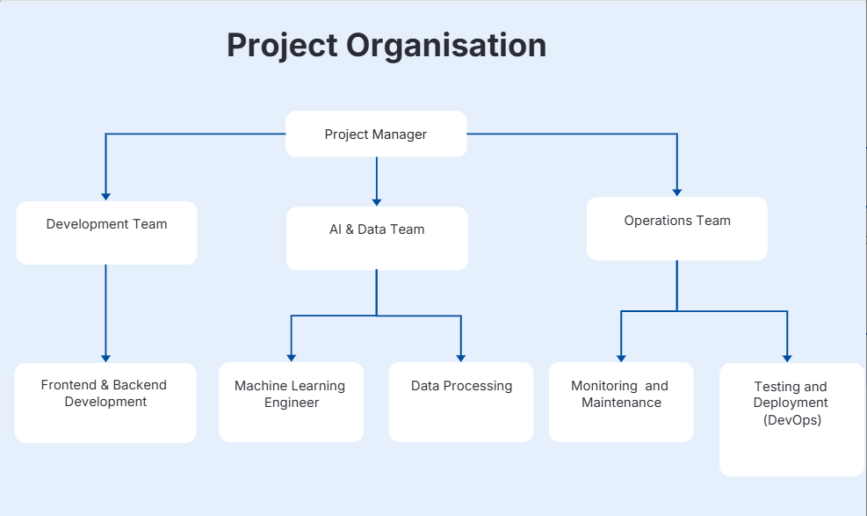

Recycling Pickup Scheduler is an online tool that was created to aid the process of requesting and scheduling recycling of houses and businesses. As indicated in the project organisation structure above, the system development is under the control of a Project Manager who is the coordinator of three key functional teams: Development, AI and Data, and Operations. The Development Team will be in charge of implementing the front and the back-end functionality, such as user registration, request management, and scheduling. The AI and Data Team is dedicated to machine learning capabilities like waste classification and scheduling optimisation and data processing tasks that are needed to facilitate these capabilities. The Operations Team manages the testing, deployment, monitoring and maintaining the system to ensure that the platform is reliable and achieves its performance requirementsrThe system architecture will be laid out in a layered architecture that will include frontend, backend and database. The user-interaction layer which is built with React takes care of user interaction like accepting a form and selecting a schedule. The business logic, including authentication, processing of requests, and AI, is created with the help of Node.js and Express. All the data about the system such as user accounts, pickup requests, schedules and logs are stored in the PostgreSQL database. The system is implemented on cloud-based platform so that it can be scaled, available and data can be handled in a secure way.
By and large, this organisational structure facilitates effective team work and fits the technical architecture such that the system can be developed, deployed and maintained effectively and that it can satisfy both functional and non-functional requirements.

